GT 0121 Hurricane MMS SML / XML Parser / Composer Design
SGL.GT0121.108

Owner: | Samantha Richards
Last revised: | 7th November 2002
Revision: | 1.00
Status: | Issued
Contributors:
Key Reviewers:
Distribution | Internal / Licensees
Approved By: |  | Approval Ref.:

Contents
1. Introduction 3
1.1 Purpose and scope 3
1.2 References 3
1.3 Open Issues 3
1.4 Glossary 3
1.5 Document History 4
2. Overview 5
3. Mini-DOM 6
4. Element Class (CMDXMLElement ) 7
5. DTD Interface 7
6. Parser 8
7. Composer 10

Introduction

Purpose and scope
This document is the design for a generic XML Parser / Composer module able to perform DTD specific syntax checking.

References
[DOM] | Document Object Model Specification http://www.w3.org/TR/REC-DOM-Level-1/
[FUNC] | SGL.GT121.002 – Hurricane MMS Functional Specification
[ISO8859-1] | 8-bit single byte coded graphics character sets, Part 1: Latin Alphabet No. 1., ISO/IEC 8859-1:1998(E)
[MMS_SMIL] | MMS Conformance Document, Draft 2 of February 2001
[SMIL] | World Wide Web Consortium (W3C): Synchronized Multimedia Integration Language (SMIL 2.0) Specification: W3C Working Draft 21 September 2000
[SMIL_MDL] | SMIL object model SGL.GT0121.114
[Unicode] | The Unicode Standard Version 3.0
[WAP-OVR] | WAP-205 MMS Architecture Overview Proposed Specification of 25 April 2001
[XML] | EXtensible Markup Language http://www.w3.org/XML/

Open Issues
The following issues need to be resolved before this document is completed.
None at present.

Glossary
The following technical terms and abbreviations are used within this document.
DOM | Document Object Model
DTD | Document Type Definition
MMS | Multimedia Messaging Services
SMIL | Synchronized Multimedia Integration Language - based on XML
XML | eXtensible Markup Language

Document History
Date | Version | Status | Description
7th Nov 2002 | 0.01 | Draft | Initial version
11th Nov 2002 | 0.02 | Draft
19th Nov 2002 | 0.03 | Draft
9th Jan 2002 | 0.04 | Draft | Changed distribution to Internal.

Overview
This design covers a module to carry out the parsing and composing of XML files. The motivation for the design was the lack of extensibility of the current SMIL Parser (GT 0121 Hurricane MMS SMIL API) and a desire to reduce the ROM footprint. This implementation, while still allowing support for SMIL 2.0 Basic [SMIL], will also allow for validation based on other DTDs. While it is recognised that speed will be compromised with this implementation, it will be offset by the increased flexibility and saving in ROM budget.
Within this document, the term ‘XML Module’ covers both the parser and the composer.
This design is based on the following assumption:
- There is a need for a parser for a number of simple XML DTDs – for example, SMIL, XML messaging, and configuration files.
- The ROM footprint of the XML Module should be significantly reduced from that of the current SMIL Parser (GT 0121 Hurricane MMS SMIL API).
- The DOM classes should have no responsibility for the parsing / composing of files.
The module comprises the following components
- A generic set of classes that can represent the contents of an XML file in an object hierarchy for efficient processing. These classes are referred to as the ‘mini-DOM’ because they use some but not all concepts from the DOM [DOM]. While the classes are generic they will be capable of performing syntax checking / validation with regard to a specific DTD (determined at run time).
- An interface class (MXMLDtd ) defining the signature for the necessary DTD validation functions. Any DTD specific validation class will be derived from this and provide an implementation of these functions. The document will be created with an MXMLDtd object.
- A parser that can read an XML file and can generate mini-DOM objects.
- A composer that can take a mini-DOM object tree and output an XML file.

Mini-DOM
The XML Mini-DOM classes are based on a subset of the DOM classes [DOM]. The Mini-DOM is a subset because it is not intended to support some of the more ambitious / obscure uses of XML. It also discards some of the theoretical layers (for example, attributes are not created as separate nodes but are member data of element objects). The Mini-DOM is not intended as a porting API whereby applications written on other platforms using the DOM can be trivially ported to the Symbian OS.
When an XML file is parsed and a Mini-DOM tree is created, the Mini-DOM classes provide an API to navigate through the document objects and to query the element attributes. When an XML file is to be composed the Mini-DOM provides an API to interrogate the elements allowing the XML Composer to produce a textual representation.
The document( CMDXMLDocument) will be created with a reference to an MXMLDtd object and will provide an API to allow validation based on DTD specific rules.
The generic element class can represent each element type, with elements being differentiated by their names
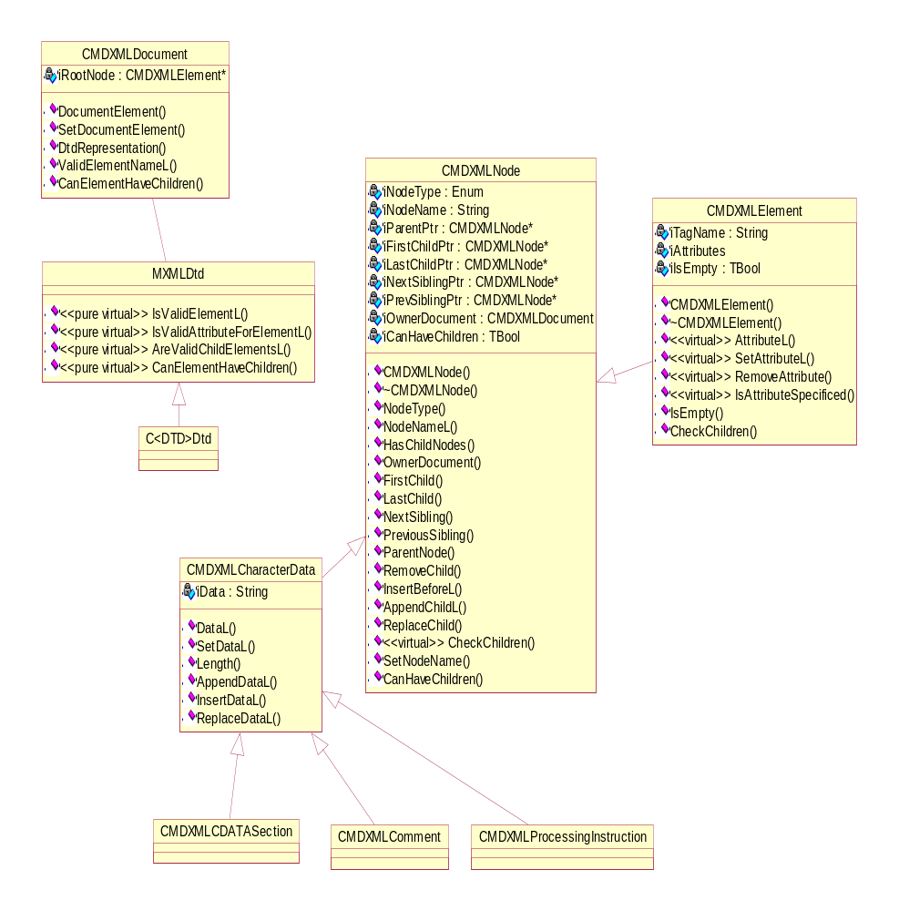

Element Class (CMDXMLElement )
The Mini-DOM is generic and its basic API provides access to all elements and attribute values. Attribute access is by name (i.e., to get the value of the ‘width’ attribute, call GetAttributeL(‘width’) or a close approximation and the value will be returned as another string).
No DTD element classes will be necessary. All elements will be constructed from the generic element class (CMDXMLElement) and will have the following functionality:
- The element class has member variables created for each element attribute defined. Each member variable has standard accessor and mutator functions defined.
- Validation of attribute values can be carried out by calling IsValidAttributeForElementL. DTD specific validation will be done (based on the MXMLDtd object passed into the document on creation).
- The element class has a CheckChildren function created to check that any child elements conform in type and order to the requirements of the DTD. (This is achieved by calling CheckValidChildren on the Dtd object owned by the document.)

DTD Interface
For the module to be useful it has to be capable of parsing based on the rules of a given DTD. To facilitate this a DTD interface class id defined from which specific DTD classes could be derived. The parser would then be able to call the DTD specific functions.
The interface will be defined as
class MXMLDtd
{
public:
virtual TBool IsValidElement(const TDesC& aElement) const = 0;
virtual TInt IsValidAttributeForElement(const TDesC& aElement, const TDesC& aAttribute, const TDesC& aAttributeValue) const = 0;
virtual TBool AreValidChildElements(const TDesC& aParentElement, const CDesCArray& aChildElements) const = 0;
virtual TBool CanElementHaveChildren(const TDesC& aElement) const = 0;
};

Parser
The XML Parser is a single-pass parser with a two-stage pipeline. The first stage is basic lexical analysis that reads in data from a source, performs some housekeeping and normalisation functions on it and passes on ‘meaningful’ sections of text to the second stage for parsing.
The following operations are performed on the input by the lexical analysis stage:
- Comments are stripped out.
- Processing instructions are stripped out.
‘Meaningful’ sections of text are as follows:
- Complete tag definitions (could be start tag, end tag or combined tag)
- Sections of text of specific CDATA sections
The second stage is to parse elements by breaking out the element name and sequence of attribute values and create generic attributes.
Built-in, character entities are replaced by their values if they have previously been defined. Any entity references that are not recognised will be left untouched
The second parser stage creates DOM objects in a tree structure by adding new elements onto the child element list of each element as appropriate. Encountering a start tag causes an element to be created under the then-current element while encountering an end tag causes the then-current element to move up the object tree. At the same time, the end tag will be compared with the relevant element to ensure that start and end tags match. If an empty element tag is encountered then the element will be created but the position for insertion of the next tag will not descend the object tree.
The XML Parser is generic and has no functionality specific to any particular DTD. Instead, validation/syntax checking will be done via the min-DOM API.
The parser carries out the act of parsing an XML file as an Active Object. In the first version, a single activation of the object will parse the whole file (and this may be desirable when the files are known to be small) but the API will support an implementation where a file is parsed over multiple activations.

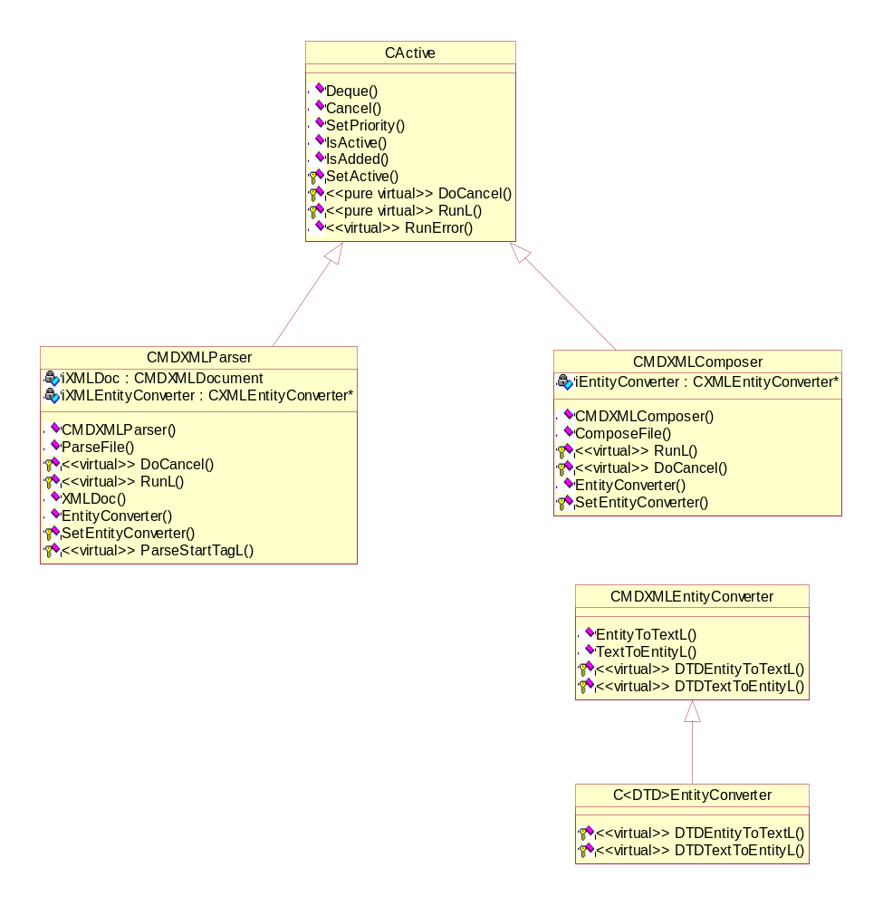

Composer
The XML Composer is presented with an object tree based on the DOM (mini or DTD-specific). It performs a tree walk for each element and using the generic element API accesses element details and outputs the text of the elements or the character data.
During the tree-walk, elements which are not empty will result in a start tag and an end tag being output. Empty elements will result in a single tag being output. Instances of characters which should be replaced by built-in entity references will be so replaced. An XML file that is parsed and then the resulting object tree fed into the composer will not necessarily create an output file that is identical to the input file (in fact, any comments may be lost and whitespace elements may well be affected as well).

